
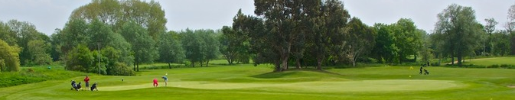
Christchurch
G.C.
FRIDAY 11th SEPT 2026
Sarah Green Golf Tournament
ENTRY FORM
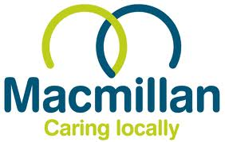

23rd Annual
Event
ENTRY FORM

Mr A C Rogers

Format

- Tournament fee of £75 per player (£300 team of four)
- 18 hole stableford competition – max. 24 handicap off yellow tees*
(*players entering with higher handicaps will be capped to 24)
- 25 teams of four players, best 3 scores per hole count
- Handicaps calculated as lower of average last 3 SGGT cards, or declared handicap

Prizes

1st three winning teams & 1st three individuals
Longest drive + Nearest the pin
Birdies and putting competitions
Best Dressed Team!!

Food & Entertainment

Included in your entry fee are:
- Bacon Baps plus Tea & Coffee on arrival
- Range balls for each golfer
- Evening meal & desserts at 6.30pm
- Followed by presentations, raffle & charity auction
- Extra tickets for family & friends only £40 pp (subject to availability/payment in advance)

Payment

Please transfer your payment direct to:

Bank Account Name: Sarah Green Golf Tournament

Bank Details Account No: 00455927 Sort Code: 30-92-02 Payment reference: “Use your team name”

Entry

Please complete the attached entry form and return to Anthony Rogers at:

Email: anthony-rogers@hotmail.co.uk

Title your email: Sarah Green Golf Tournament - Entry

Tel: 07832 249826

Supported by Macmillan Caring Locally. Registered charity number: 1189412
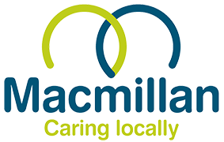
Sarah Green Golf Tournament 2026

Please type the information requested in the grey boxes:

Team Name

 | Full Name | Handicap
Captain
Player 2
Player 3
Player 4

Buggies | Due to high demand, limit of one buggy per team.  Selected by ballot, to enter please tick this box.  Ballot drawn one month before event. £40 per buggy. | Tick here….

Captain’s Email

Payment is by Bank Transfer only:

Bank Account Name: Sarah Green Golf Tournament

Bank Account No: 00455927
Sort Code: 30-92-02
Payment reference: “Use your team name”

Amount Transferred | £ ___________ £75 pp / £300 team
Transfer Date | (Day) (Month) 2026

Please Send to:

Email: anthony-rogers@hotmail.co.uk

Title your email: Sarah Green Golf Tournament - Entry
Thank you
Supported by Macmillan Caring Locally. Registered charity number: 268218

Supported by Macmillan Caring Locally. Registered charity number: 1189412

