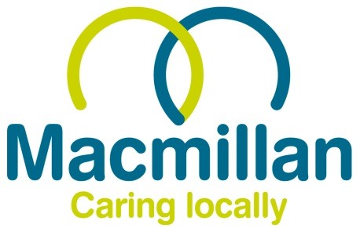

**SARAH GREEN GOLF TOURNAMENT**

**2024 – Prize Winning Results:**

* Individual Stapleford
  + 1st – Dan Mersh (41 pts)
  + 2nd – Ben Richards (40 pts)
  + 3rd – Brian Dawkins (39 pts)
* Team Stapleford
  + 1st – Southern Slicers (116 pts)
  + 2nd – Here Fore Beer (112 pts) – Count Back
  + 3rd – Dude, Where’s my Par? (112 pts)
* Pink Ball Competition (Team)
  + No balls returned!
* Nearest the Pin (13)
  + Simon Trimnell
* Longest Drive (Hole 3)
  + Connor Williams
* Straightest Drive Competition (Hole 10)
  + Kevin Aspin
* Nearest The Pin In 2 (Hole 8)
  + Jason Wills
* 2’s Competition
  + Gavin Trimnell
  + Dan Mersh (with an Eagle!)
  + Connor Williams
  + Simon Trimnell
* Best Team Outfit/Hats
  + Who needs Andy we've got Conner
* Fairway Super Heavyweights (Team)
  + The Foresaken (428 Shots Gross)
* Chump of the Day
  + Daniel Cooper