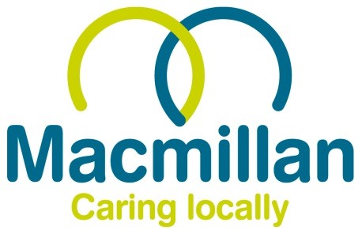

**SARAH GREEN GOLF TOURNAMENT**

**2023 – Prize Winning Results:**

* Individual Stapleford
  + 1st – Buster Edwards (36pts)
  + 2nd – Simon Trimnell (35 pts) on countback
  + 3rd – Jason Charlton (35 pts)
* Team Stapleford
  + 1st – Sundays Drivers (112 pts)
  + 2nd – Badders Bandits (103 pts)
  + 3rd – No Fore Kin Idea (97 pts)
* Pink Ball Competition (Team)
  + Banders Bandits
* Nearest the Pin (7)
  + John Davidson
* Longest Drive (Hole 3)
  + Pete Ford
* Straightest Drive Competition (Hole 10)
  + Adam Darnell
* Nearest The Pin In 2
  + Michael O’Leary
* Putting Competition:
  + Chris Blanche
* 2’s Competition
  + Paul Lynch
  + Brian Dawkins
  + Pete Ford
* Best Team Outfit/Hats
  + Shankin Steven’s
* Fairway Super Heavyweights (Team)
  + Birdies, Bogeys, Beer & B#####! (472 Shots Gross)